Budget Rent A Car 
of British Columbia

Global Information System

Foreign Contract Check-in Business Design

Version 2.00

Note: The information contained in this document is confidential and may not be disclosed to any parties outside of Budget Rent a Car of British Columbia without written consent by one of its officers.
Copyright (C) 2000 Budget Rent a Car of British Columbia
Table of Contents
1. Functional Area Business Design 1
1.1. Contracts 1
1.1.1. Process Description 1
1.1.2. Screens 1
1.1.2.1. Foreign Contract Check In Screen 1
1.1.2.1.1. Check In Vehicle Tab 8
1.1.2.1.2. Rate Tab 13
1.1.2.1.3. Payment Tab 16
1.1.2.1.4. Comments Tab 24
1.1.2.1.5. Renter Tab 26
2. Revision History 29
2.1. Version 2.00 29

Functional Area Business Design

Contracts

Process Description

Screens

Foreign Contract Check In Screen
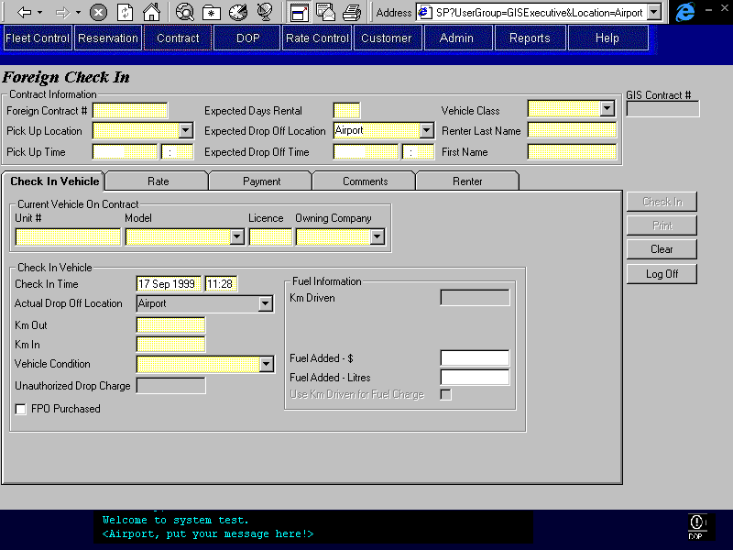
Purpose
The purpose of the Foreign Contract Check In screen is to both create a foreign contract (foreign rental location) and check in a foreign vehicle on that contract.
The screen is organized into six areas: the base screen and five tabs. The base screen allows the CSR to enter the basic information about the contract on the section above the tabs. This section is similar to the area above the tabs on the regular contract screens. There are five tabs that will then be used to enter the remaining information for the contract. The tabs contain the remaining required contract information and are categorized as follows:
Check In Where the CSR enters vehicle and check in information so that GIS is able to
Vehicle: add the foreign vehicle to BRAC’s fleet and check in the contract.
Rate: Where the information that determines the amount to be charged for the rental is entered and displayed. The base rate used for the contract can be viewed and/or entered. Manual charges for coverages and extras may be added.
Payment: Where payment and authorization information is entered. Buttons are available to:
- Identify alternate payment organizations and assign rental charges to them.
- Record details of cash deposits and credit card authorizations, deposits, and refunds.
Comments: Where comments may be selected and entered by the CSR. There are two types of comments, those that will show on the printed contract and those that will not.
Renter: Where the renter and additional driver information is entered
Check In, Print, and Clear buttons are available on the far right.
Screen Hierarchy
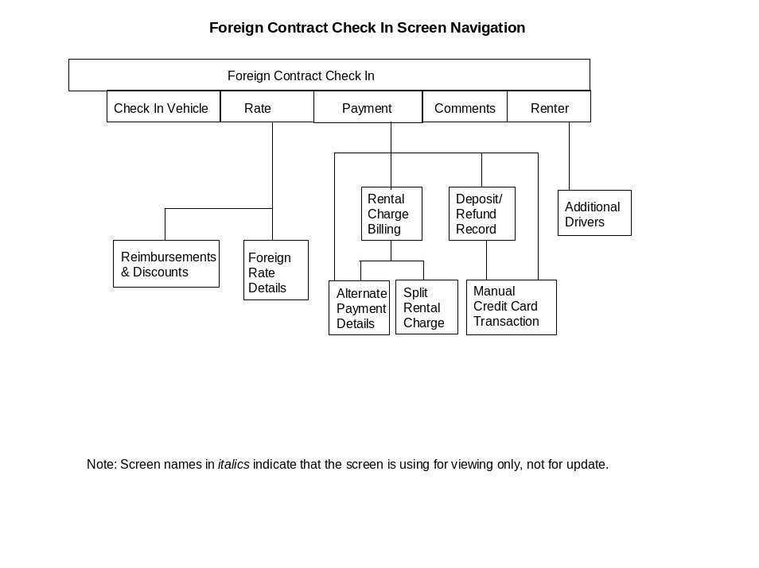
Navigation
N/A
Functions
Check In: Creates the contract.
Adds the vehicle to BRAC’s fleet and creates vehicle model if necessary. See Technical Notes for more detail.
Checks in the currently checked out vehicle. Sets the status of the vehicle as indicated by the CSR on the screen. Disables the Check In button. Makes all fields read only.
When the contract is checked in the following must be completed:
- Rate details must be entered.
- The balance owing must be zero if the Interbranch message is not visible.
- For each direct bill organization (Contract Billing Party with Billing Method ‘Direct Bill’ or ‘Voucher’) that is being billed for all or part of the rental charges:
- Add the balance owing for the organization at check in to the daily contract charges for the organization (AR Credit Authorization, Daily Contract Total).
- Record the balance owing for the organization at check in as an A/R contract payment (see Contract Check In in the Contracts Part 1 document)
- Generate Accounting Interface entries for any deposits received or refunds issued and for each A/R contract payment. For details, see the section on Accounting Interface Entries for Contract Check In.
For more details about what fields are updated and A/R transactions see the Technical Notes in Contract Check In in the Contracts Part 1 document.
Print the contract.
Print: Prints the contract. Disabled until the contract is checked in.
Clear: Disabled once a credit card authorization or a credit card or cash deposit has been processed.
Controls
Req*: Y – always mandatory
N – always optional
S – sometime optional (see Comments for details)
D – display only
Field | Source | Req* | Validation | Comments
Contract Information
Foreign Contract # | Contract, Foreign Contract Number | Y
Pick Up Location | Contract, Pick Up Location ID | Y | Foreign location only (non-BRAC) | Location name displayed.
Pick Up Time | Contract, Pick Up On | Y | Date & Time
Expected Days Rental |  | Y | Difference between Pick Up Time and Drop Off Time.  Numeric | Either Expected Drop Off Time or Expected Days Rental is entered. One will be automatically calculated from the other.
Expected Drop Off Location | Contract, Drop Off Location ID | Y | Value controlled by Location table.  Rental locations only. | Location name is displayed.  Defaults to current location.
Expected Drop Off Time | Contract, Drop Off On | Y | Date & Time | Either Expected Drop Off Time or Expected Days Rental is entered. One can be automatically calculated from the other.
Vehicle Class | Contract, Vehicle Class Code | Y | Value controlled by Vehicle Class table. | Vehicle Class Name is displayed.
Renter Last Name | Contract, Last Name | Y | Free form text.
Renter First Name | Contract, First Name | Y | Free form text.
GIS Contract # | Contract, Contract Number | D | GIS generated
Technical Notes
Adding the Foreign Vehicle to BRAC’s Fleet:
Vehicle.Vehicle Owning Company = Owning Company field
Vehicle.Unit Number = GIS generated
Vehicle.Foreign Unit Number = Unit Number field
Vehicle.Current Rental Status = Available
Vehicle.Current Location ID = Vehicle On Contract. Actual Drop Off Location ID (Actual Drop Off Location field)
Vehicle.Vehicle Class Code = Contract.Vehicle Class Code (Vehicle Class field)
Vehicle.Vehicle Model ID = Vehicle Model field
Vehicle.Current Condition Status = Vehicle On Contract.Vehicle Condition (Vehicle Condition field)
Vehicle.Current Licence Plate = Licence
Vehicle.Current Vehicle Status = Rental
Vehicle.Rental Status Effective On = Check In Date
Vehicle.Vehicle Status Effective On = Check In Date
Vehicle.Condition Status Effective On = Check In Date
Vehicle.Smoking = No
Vehicle.Deleted = No
Vehicle.Current Km = Km In
Create Vehicle Model:
If the vehicle model entered does not exist in the database then the model will be created in the Vehicle Model Year Table. The following fields will be populated:
Vehicle Model Year.Vehicle Model ID = GIS generated
Vehicle Class Vehicle Model Year.Vehicle Class Code = Vehicle Class
Vehicle Model Year.Model Name = Model
Vehicle Model Year.Foreign Model = Yes
Creating the Contract:
For following fields are required to create a contract but are not listed in the control section. The values will be as follows:
Contract.Copied = No
Contract.Status = Closed
Contract.Authorized By = Credit Card or Cash (Renter Authorization method’s only)
Contract.Renter Driving = Yes
Contract.Do Not Extend Rental = No
Contract.Do Not Replace Vehicle = No
Contract.Apply Violation Rate = No
Interbranch Balance = Balance Owing at Check In (Only when Contract.Interbranch Flag is Yes)
Creating the Vehicle On Contract:
The following fields are required to create a contract but are not listed in the control section. The values will be as follows:
Vehicle On Contract.Unit Number = Vehicle.Unit Number
Vehicle On Contract.Contract Number = Contract.Contract Number
Vehicle On Contract. Checked Out = Contract.Pick Up On (Pick Up Time field)
Vehicle On Contract.Pick Up Location ID = Contract.Pick Up Location ID (Pick Up Location field)
Vehicle On Contract.Expected Check In = Contract.Drop Off On (Expected Drop Off Time field)
Vehicle On Contract. Expected Drop Off Location ID = Contract.Drop Off Location ID (Expected Drop Off Location field)
Vehicle On Contract.Actual Vehicle Class Code = Contract.Vehicle Class Code (Vehicle Class field)
Vehicle On Contract.Check In By = User ID who completed check in

Check In Vehicle Tab
Purpose
The Check In Vehicle tab is used to complete the check in of the foreign vehicle that is currently checked out on a foreign contract. This will transfer the responsibility for the vehicle from the Renter to Budget. No other vehicle may then be checked out on the contract. All optional extras that are currently rented will also be checked in or ended at the same time as the vehicle check in.
Checking In a foreign vehicle using this screen will add the vehicle to BRAC’s fleet.
Navigation
N/A
Functions
N/A
Controls
Req*: Y – always mandatory
N – always optional
S – sometime optional (see Comments for details)
D – display only
Field | Source | Req* | Validation | Comments
Current Check Out Vehicle
Unit # | Vehicle, Foreign Unit Number | Y |  | Corresponding Vehicle, Unit Number will be used for Vehicle On Contract, Unit Number
Model | Vehicle, Vehicle Model ID | Y | Assisted by Vehicle Model Year table. For the selected Vehicle Class. The model name entered cannot match an existing model name for a difference vehicle class. | Model Name is displayed
Licence | Vehicle, Current Licence Plate | Y
Owned By | Vehicle, Vehicle Owning Company | Y | Value controlled by Owning Company table.
Check In Vehicle
Check In Time | Vehicle On Contract, Actual Check In | Y | Date and time. | Default to current time.
Actual Drop Off Location | Vehicle On Contract, Actual Drop Off Location ID | Y | Value controlled by Location table.  Rental locations only. | If at a rental location then value defaults to that location and cannot be updated.  If at a non-rental location then may select any rental location.
Km Out | Vehicle On Contract, Km Out | Y | Numeric
Km In | Vehicle On Contract, Km In | Y | Numeric
Vehicle Condition | Vehicle On Contract, Vehicle Condition | Y | Value controlled by Vehicle Condition table.
Unauthorized Drop Charge | Contract Charge Item, Amount | S | Currency | Charge Item Type = Drop Off Charge.  Mandatory if Expected Drop Off Location and Actual Drop Off Location are different.  See Technical Notes below.
FPO Purchased | Vehicle On Contract, FPO Purchased | N
FPO Charge | Vehicle On Contract, Foreign FPO Charge | S | Currency | Mandatory if FPO Purchased is checked.
Fuel Information |  |  |  | Only visible if FPO Purchased is not selected. If visible one of the below methods must be entered.
Km Driven |  | D |  | Km In – Km Out
Fuel Level | Vehicle On Contract, Fuel Level | N | Values are in 8ths or Full or Empty.
Fuel Remaining – Litres | Vehicle On Contract, Litres of Fuel Remaining | N | Numeric
Fuel Added - $ | Vehicle On Contract, Fuel Added $ | S | Currency | One of Fuel Added - $ or Fuel Added – Litres must be added if the Vehicle Model entered does not have fuel tank information.
Fuel Added – Litres | Vehicle On Contract, Fuel Added Litres | S | Numeric | One of Fuel Added - $ and Fuel Added – Litres must be added if the Vehicle Model entered does not have fuel tank information.
Use Km Driven for Fuel Charge |  | N |  | Disabled if any other Fuel Charge method is entered. Disabled if Vehicle Model entered does not have fuel tank information.
Technical Notes
Drop Off Charge
The drop charge will be determined in the Rate details (Quoted Vehicle Rate.Authorized Drop Off Charge) unless the Unauthorized Drop Charge is entered. If the Unauthorized Drop Charge is entered it will override any other drop charge.

Rate Tab
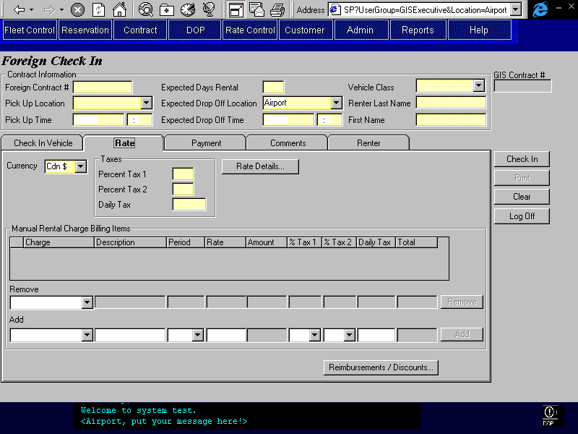
Purpose
The Rate tab allows the CSR to enter rate information and any manual charges that may be required. Manual charges will be required for coverage, optional extra, and additional driver charges. Note that while manual charges may be entered on this tab, the allocation of billing is completed in the Rental Charge Billing screen. The Manual Rental Charge Items section will behave as described in the Rental Charge Billing Screen with the exception that the Bill To field is hidden.
Reimbursements and Discounts may also be accessed from this tab. No additional authority is required to apply reimbursements or discounts to a foreign check in contract.
All charges, reimbursements, and discounts are assumed to be in the currency selected for the contract.
Navigation
Rate Details: Opens the Non-GIS Rate Details screen where the CSR may enter the rate information for this contract. See the Rentbacks and Interbranch Changes document for the description of this screen.
Reimbursements Opens the Reimbursements and Discounts sub-screen. This screen is
/Discounts: described in the Contracts Part 1 document.
Functions
N/A
Controls
Req*: Y – always mandatory
N – always optional
S – sometime optional (see Comments for details)
D – display only
Field | Source | Req* | Validation | Comments
Currency | Contract, Currency ID | Y | Value controlled by currency table.  Locked after any payment has occurred. | Default to Cdn $
Taxes
Percent Tax 1 | Contract, Percentage Tax1 | Y | Percentage, 0% allowed
Percent Tax 2 | Contract, Percentage Tax2 | Y | Percentage, 0% allowed
Daily Tax | Contract, Daily Tax | Y | Currency, $0.00 allowed
Manual Charges |  |  | Charge Types available for selection are controlled by the Rentback Charge Category in the Look Up table. | As described in the Rental Charge Billing Screen with the Bill To field hidden. Defaults Bill To to Renter.
Technical Notes
Discount Security
The Discount Security is the same as for the other GIS screens. To give the CSRs the ability to add discounts the override permission should be added to their user group for the Foreign Check In screen.

Payment Tab
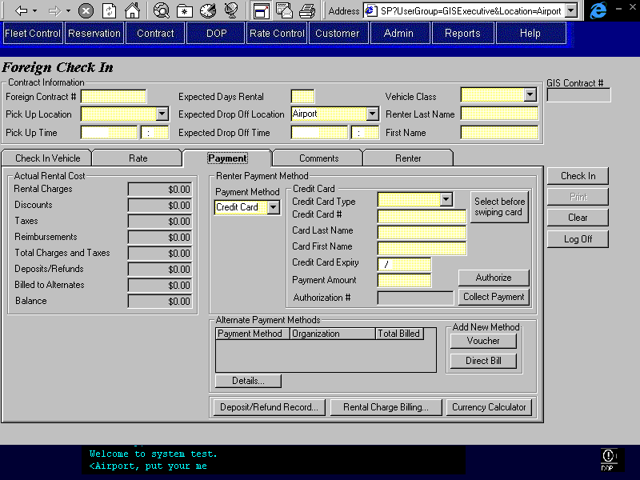
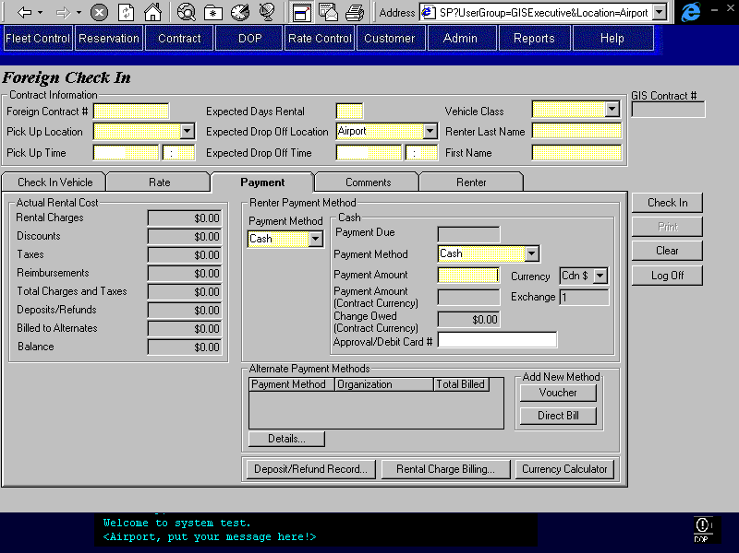
Purpose
The payment tab is for processing payments and authorizations, as well as identifying Alternate Payment Methods if applicable. The Deposit/Refund screen is available for the processing or recording (depending on the location entered) of additional payments and authorizations. The Rental Charge Billing screen is available for assigning the charges to the renter or alternate payment methods.
All foreign contracts are treated as though authorized by the renter. For contracts in Canadian currency the following rules will apply:
- If no deposit has been processed or recorded and a credit card authorization exists for the contract, then the Interbranch message will be displayed and the balance will not be required to be zero at check in.
- If a deposit has been recorded or processed at this time, or if no credit card authorization has been recorded then the balance owing must be zero upon check in.
For contracts in US currency the following rules will apply:
- If a credit card deposit or authorization has been recorded or processed, then the Interbranch message will be displayed and the balance will not be required to be zero at check in.
- If no credit card deposit or authorization has been recorded or processed, then one of the following is required at check in:
      - An authorization on a credit card must be completed for the amount of the balance owing. The authorization will be in Cdn$ (no conversion will be done).
      - The balance owing must be collected by a cash method.
- No credit card payments will be processed when the contract currency is US$.
These are the same rules as outlined in the Rentback and Interbranch Changes document.
All recorded payments and authorizations (those done at foreign locations) are assumed to be in the currency of the contract (defined on the rate tab). Credit card payments and authorizations processed at the check in location (BRAC location) will be completed in Cdn$. Note that a credit card payment will never be processed for a US$ contract. Cash payments may be taken in Cdn$ or US$ currency and will be converted into the contract currency.
Navigation
Deposit/Refund Opens the Deposit/Refund Record screen where the details of cash deposits
Record: and refunds, credit card deposits and refunds, and credit card authorizations can be viewed and added.
When transactions are added they are either processed or simply recorded depending on the location that is selected. If the location is foreign then the transaction will be recorded and not processed, otherwise the transaction is processed. In the case of a foreign location, for credit card transactions, the only required fields are the location, credit card type, and amount.
The Deposit/Refund Record screen is described in the Contracts Part 1 document.
This button will be the first tab stop on this screen.
Rental Charge Opens the Rental Charge Billing Screen. Adding and Deleting Manual
Billing: Charges will be disabled. The Rental Charge Billing screen is described in the Contracts Part 1 document.
Currency Calculator: Opens the Currency Calculator sub-screen where amounts may be converted from one currency to another. No payments or refunds occur in this sub-screen.
Voucher: Opens the Voucher Alternate Payment Method Details screen, where the CSR may search and select the appropriate alternate billing organization and enter the required details. Upon exiting this sub-screen, the Rental Charge Billing screen will be opened. Note that restricting the selection of the billing organization to the Renting Location is procedural. The Voucher Alternate Payment Method Details screen is described in the Contracts Part 1 document.
Direct Bill: Opens the Direct Bill Alternate Payment Method Details screen, where the CSR may search and select the appropriate alternate billing organization and enter the required details. Note that restricting the selection of the billing organization to the Renting Location is procedural. The Direct Bill Alternate Payment Method Details screen is described in the Contracts Part 1 document.
Details: Opens the appropriate Alternate Payment Method Details screen (Voucher
(Alternate or Direct Bill), depending on which existing alternate payment method is
Payment Method) selected, so that the CSR can view and update information. The search criteria and search results sections will be hidden.
Functions
Authorize: Processes an authorization for the amount specified on the screen for
(Credit Card) the entered credit card. This amount will always be in Cdn$ currency. For details on the credit card authorization process, see the Credit Card Interface design document.
If the automated payment facility is not available or the credit card type has no automatic payment, opens the Manual Credit Card Transaction sub-screen and populates it with the credit card and authorization amount information from this tab. After the sub-screen is closed, the authorization number returned will be displayed on this tab.
Collect/Refund Collects payment or issues refund for the amount specified on the screen for
Payment: the entered credit card. Disabled if contract currency is US$. For details
(Credit Card) on the credit card payment process, see the Credit Card Interface design document.
If the automated payment facility is not available or the credit card type has no automatic payment, opens the Manual Credit Card Transaction sub-screen and populates it with the credit card and payment or refund amount information from this tab. After the sub-screen is closed, the authorization number returned will be displayed on this tab.
Controls
Req*: Y – always mandatory
N – always optional
S – sometime optional (see Comments for details)
D – display only
Field | Source | Req* | Validation | Comments
Actual Rental Cost
Rental Charges |  | D |  | Calculated by GIS  See the Calculate Non-GIS Rental Charges Function in the Rentback Changes document.
Discounts |  | D |  | Sum of all discounts applied to contract. Total = Sum of all discounts on Reimbursements / Discounts sub-screen.
Taxes |  | D |  | Calculated by GIS, based on rental charges less discounts. Sum obtained from GST, PST, and PVRT totals in Rental Charge Billing.
Reimbursements |  | D |  | Sum of all reimbursements applied to contract. Total = Sum of all Reimbursements on Reimbursements / Discounts sub-screen.
Totals Charges and Taxes |  | D |  | Sum of rental charges, discounts, taxes and reimbursements (four fields directly above on screen).
Deposits/Refunds |  | D |  | Sum of all deposits and refunds applied to contract where payment type is cash or credit card. Total = Sum of all Payments and Refunds in Deposit/Refund Record sub-screen.
Billed to Alternates |  | D |  | Sum of all rental charges and taxes billed to alternate payment organizations. Total = Sum of Total Billed field in Alternate Payment Method grid.
Balance | Contract, Interbranch Balance | D |  | Total Charges and Taxes, less Deposits/Refunds and Billed to Alternates  If Interbranch message is displayed save balance to Contract.Interbranch Balance at Check In.
Interbranch Message |  | D |  | For $Cnd Contracts: Displayed only when no deposit or payment has been processed or recorded for the contract.  For $US Contracts:  Display only when a credit card transaction (deposit or authorization) has been recorded or processed.
Payment Method | Contract Payment Item, Payment Type | Y | Credit Card, Cash
Credit Card |  |  |  | Display if Payment Method is Credit Card. Hide otherwise. Populated from credit card swipe (if done).
Credit Card Type | Credit Card, Type | Y | Value controlled by Credit Card Type table.
Credit Card # | Credit Card, Number | Y | Check Digit, see Credit Card Interface document for more details.
Card Last Name | Credit Card, Last Name | Y
Card First Name | Credit Card, First Name | Y
Credit Card Expiry | Credit Card, Expiry | Y | Date (month and year)
Payment Amount | Contract Payment Item, Amount | Y |  | Default to Balance.
Authorization # | Credit Card Payment, Authorization Number | D |  | Populated only when payment or authorization completed.
Payment Method Cash |  |  |  | Display if Payment Method is Cash. Hide otherwise.
Payment Due |  | D |  | Calculated by GIS, value = Balance.
Payment Method | Cash Payment, Cash Payment Type | Y | Value controlled by Cash Payment Type table | Defaults to Cash
Payment Amount | Cash Payment, Foreign Currency Amount Collected | Y |  | Defaults to Payment Due.
Currency | Cash Payment, Currency ID | D |  | Defaults and locks to contract currency.  Currency is displayed
Payment Amount (Contract Currency) | Contract Payment Item, Amount | D | Must be greater than or equal to default. (Validated at Check In)
Exchange | Cash Payment, Exchange Rate | D |  | Defaults to current exchange rate for Currency
Change Owed (Contract Currency) |  | D |  | Calculated: Payment Amount (Contract Currency) – Payment Due. Red if negative.
Approval/Debit Card # | Cash Payment, Identification Number | N
Alternate Payment Methods |  |  |  | See description in the Contracts Part 1 document.
Technical Notes

Comments Tab
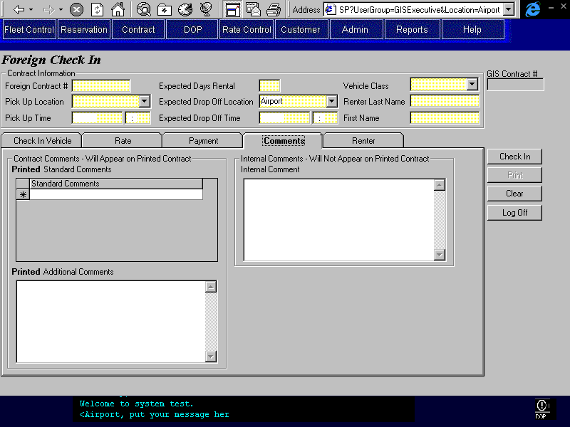
Purpose
The Comments tab is used to view and enter comments about the contract. This will facilitate communication between different CSRs who may work on the same contract. Two types of comments can be entered; comments that will appear on the printed contract and comments that will not appear on the printed contract.
The Contract Comments section contains the comments that will be printed on the contract. The CSR may select comments from a pre-existing list or enter free text to appear on the printed contract.
The Internal Comments section contains the comments that are for internal use only and will not appear on the printed contract. The internal comments will be saved along with the user id and the time of save.
Navigation
N/A
Functions
N/A
Controls
Req*: Y – always mandatory
N – always optional
S – sometime optional (see Comments for details)
D – display only
Field | Source | Req* | Validation | Comments
Contract Comments
Printed Standard Comments | Contract Print Comment, Standard Print Comment | N | Values controlled by Contract Print Standard Comment table.
Printed Additional Comments | Contract, Print Comment | N | Free form text. Maximum length 255 characters.
Internal Comments
Internal Comment | Contract Internal Comment, Comments | N | Free form text. Maximum length 255 characters.
Technical Notes
When a new internal comment is saved to the Contract Internal Comment table, the user ID of the person who entered the comment and the date and time that the comment was saved must also be saved.
The comments tab on the Foreign Check In screen is identical to the comments tab in the Contract Open/Check Out screen with the exception that there are no reservation comments.

Renter Tab
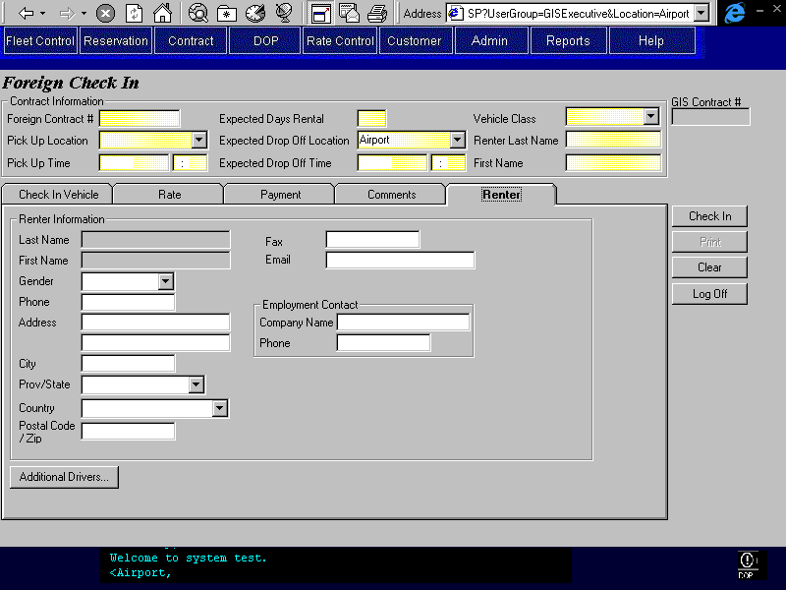
Purpose
The Renter tab allows the CSR to enter renter and additional driver information. The CSR may enter the renter’s contact information and their company name and phone number. The renter’s last and first name are display only here as they are required entries in the top section of the screen (above the tabs).
The CSR will be able to record information about any additional drivers by pressing the “Additional Drivers” button. The only mandatory fields for additional drivers are type, last name, first name and valid from and to dates. No rental charge items will be created for additional drivers. Additional driver charges will have to be added to the contract as manual charge items.
Navigation
Additional Drivers: Opens the Additional Drivers screen so that additional drivers can be added to the contract. See Contracts Part 1 for more details about this screen.
The only mandatory fields for spousal and other additional drivers are type, last name, first name and valid from and to dates. Mandatory fields for company drivers are the valid from and to dates.
The Search Customer button will be invisible.
Functions
N/A
Controls
Req*: Y – always mandatory
N – always optional
S – sometime optional (see Comments for details)
D – display only
Field | Source | Req* | Validation | Comments
Renter Information
Last Name | Contract, Last Name | D |  | Populated from Renter Last Name field located above the tabs.
First Name | Contract, First Name | D |  | Populated from Renter First Name field located above the tabs.
Gender | Contract, Gender | N | Male, Female
Phone | Contract, Phone Number | N
Address | Contract, Address 1, Address 2 | N
City | Contract, City | N
Province/State | Contract, Province/State | N | Entry assisted by Province table.  Must be valid province or state if Country is Canada or US.
Country | Contract, Country | N | Entry controlled by Country table.
Postal Code/Zip | Contract, Postal Code | N | Must match Canadian postal code format if Country is Canada. -
Fax | Contract, Fax Number | N
E-mail | Contract, Email Address | N
Employment Contact
Company Name | Contract, Company Name | N
Phone | Contract, Company Phone Number | N
Technical Notes

Revision History

Version 2.00
- Clean up documentation and make consistent with the GIS standards.

